Chapter -06

* Click-through rate is the ratio of clicks on a specific link to the number of times a page,email or advertisement shown.
* Click through rate fpr video ads on desktops are more than 5 times higher than for display ads
* Research by comsc has found that retail site viewers who view videos are 64% more likely to purchase
* As of june 2016, top 100 global brands collectively have over 3000 youtube channels with over 850,000 videos that have attracted more than 63 billion views
* Onabrush wagstaff owner, jeffrey Harmon part-timer made a youtube channel today the channel has 120 videos around 180k subscribers and more than 52 million video views(more than major brands such as colgate and johnson & johnson.
* True view ad format→avaialable on both desktop and mobile devices,launched in 2010 trueview add allow viewers t skip the ad after 5 seconds and go directly to the video they want to watch.the advertises is not changed unless the viewer watches the full ad or for longer ads at least 30 secs Trueview ads in fact give advertisers five free seconds of branding
* Trueview also allows advertisers to use what google calls dynamic remarketing which allows advertisers to show ads based on what users previously views on the advertisers website
* True view ads encourage advertisers to deliver ads that ppl actually want to watch and engage with
* One of advertisers major concerns is the issue of viewability whether video ads are actually seem
* As a communication tool, the internet affords marketers new ways of contacting millions of potential customers at costs far lower than traditional media.
* The final principle of marketing and sales is “know thy customer”|

—> worldwide around 3.4 billion ppl are online(2016) [4.82 billion nowadays]

→ women are slightly more likely to purchase online than men

→ online banking is more popular with men than women

* Iconoclast → a person who attacks or criticizes of the established beliefs or institutuions

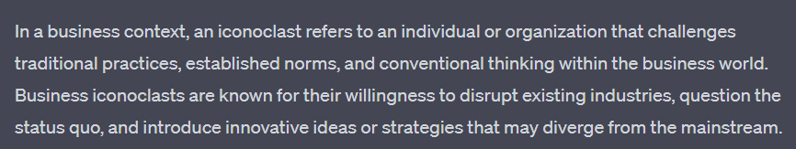

* A study of 6000 social network users found that networks have a powerful influence on shopping and purchasing behavior
* An estimated 40% of social media users have purchased an item after sharing or favoring it on fb, pinterest or twitter.
* Unexpectedly social networks increase research online, followed by purchase offline, driving purchase traffic into physical stores where the product can be seen,tried and then purchased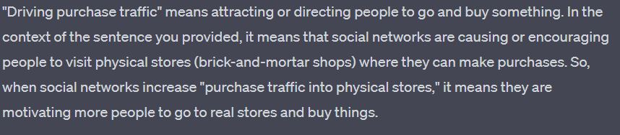

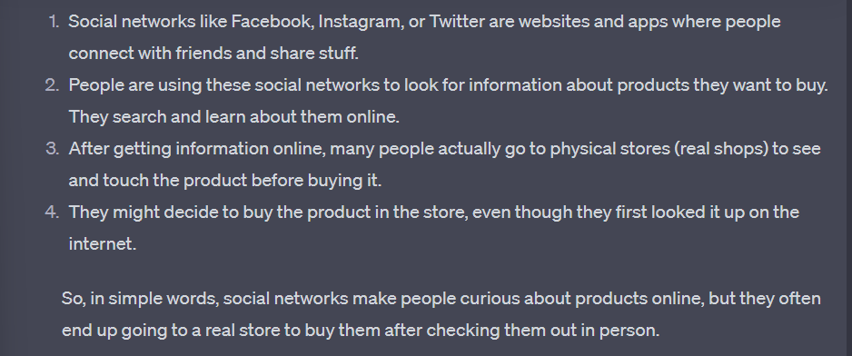

* Membership in an online brand community like fond’s fb page and community has a direct effect on sales.
* Amazones recommender systems(like consumers who brought this item also bought this….) create co-purchase networks where ppl do not know each other personally but nevertheless triple the influence of complementary products.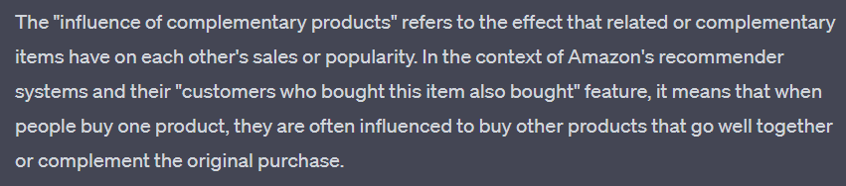
* Models of consumer behavior attempt to predict or “explain” what consumers purchase and where when how much and why they buy
* Why consumer choose online channel??
* Lower prices
* Shop from home
* Shop open for 24/7
* Easier to compare and research products and offers

Consumer Decision Process 🙂

Q- once online why do consumer actually purchase a product or service at a specific site?

* Purchaser trust the seller
* Lower price
* Free shipping
* Availability of an online coupon( point system like shopno or membership system like Easy)
* Consumer decision

1. Awareness of need
2. Search for more info
3. Evaluation of alternatives
4. Actual purchase decision
5. Post purchase contact with the firm

* Post purchase

Online→ social networks,ratings ,online reviews

Offline→ warranties,parts & repair

Clickstream behavior 🤔

Presupposes no prior “deep” knowledge of the customer and can be developed dynamically as customers use the internet. For instance the success of search engine marketing(the display of paid advertisements by search engine) is based in large part on what the consumer is part on what the consumer is looking for at the moment and how they go about looking

Sequence of data checking

* examining the detailed data
* General clickstream data is used(days since last visit,past purchases)
* If available demographic data is used (region city and gender)
* Conduit meaning channel
* E Commerce is a major conduit and generator of offline commerce and online traffic is driven by offline brands and shopping

Like: seeing something on some bill board and search it online.

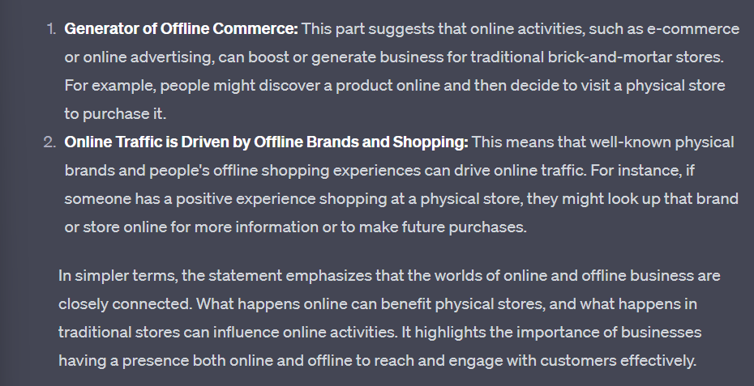

* These considerations strongly suggest that ecommerce and traditional commerce are coupled and should be viewed by merchants as part of a continuum of consuming behavior and not as radical alternatives to one another
* Thanku fr the gifts bebe
* I loveeeeeeeeeeeeeeeeee it
* TwT
* Love you
* No me moreee
* Me most
* Me mostesttttt
* Wish i coild gib u a kissie
* Dio amk box e jomay rkho
* For whennnnnn 🙁❤️❤️❤️❤️❤️❤️❤️😢❤️❤️❤️❤️?
* Jokhon ar kew tkhbe na amdr sathe
* Kothay tahile to ar hbei na 😣hbe toh jokhojn amra private time pai
* Pai na toh ar
* Paboh soon
* Koto soon
* Ektu soon
* Nouuuuuuuuuu
* Huu pabo
* Kothay amr to date eo jai na
* Jboh amraa free time pelwi
* But i lovedd the gifts thenkuu , kinyu tumi toh khule check koroni ekhono
* Hu ota to room e na dekhboo privately ekhane samner meye ta ke dekhabo naki amr bf ki diseeee
* Assa thikase
* Mmhmmm lob u
* Lobutu
* Sotti toh???huuuoki pori ekhon ch-6 sesh kori amra